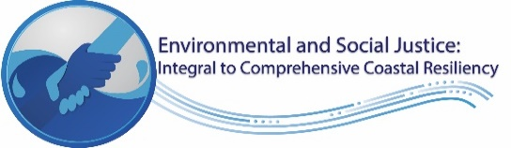

USACE, Galveston District (SWG) Winter 2022
Stakeholders Partners Forum

Thank you for taking the time to participate in this forum evaluation. Your comments will enable us to better plan and execute future forums and tailor them to meet your needs.

- What did you enjoy MOST about the forum (e.g., topics, speakers, format?)

______________________________________________________________________________

- What can we do BETTER for the next event (e.g., different speakers; more of a give-and-take; fewer slides)

- What DIDN’T we cover that you specifically wanted to see? What would you like to see MORE of at our next event?

- Any additional comments.

NAME (optional) ________________________________________________________________________

