Cover Page

Title
Permit/Application Number

Applicant: Name
Address
Phone
Contact Person
Contact Email

Consultant: Name
Address
Phone
Contact Person
Contact Email

Date
Table of Contents

Introduction

Background

Methods

Results

Conclusions

References

Attachments

Attachment 1 – Exhibits
- Overview,
- Plan View
- Cross Section
- Sampling Locations

Attachment 2 – Sampling Analysis Plan (SAP)

Attachment 3 – Case Narrative

Attachment 4 – Tables

Attachment 5 – Approved USACE Permit

EXAMPLE REPORT

INTRODUCTION

AGENT was contracted by the APPLICANT to provide assistance with the sampling, analysis, and reporting for maintenance dredging the PROJECT to comply with requirements of the Clean Water Act (CWA). The maintenance dredging was performed from _______ to ______.

Please consider this final letter report and attachments as satisfying the requirements of the CWA. Attached to this hardcopy is a CD containing all raw chemistry data, Water Quality Data sheets, and Excel and Word files.

BACKGROUND

The project site is located at _______ (Figure 1). Historically the site has been utilized as a _________. The site is surrounded by _________. The surrounding properties include _______. The project was originally authorized under SWG-___-____ (Attachment 5) which authorized the dredging of _______ and placement into PA ______ Amendments? were authorized in ___ for the __________.

Current conditions show the elevation to be ____ (Figure 3 – Cross Section) Post-dredging elevation will be ____ Approximately ____ cubic yards will be dredged during the maintenance dredging. Dredging will be accomplished utilizing MECHANICAL/HYDRAULIC PIPELINE dredge.

METHODS

All sampling stations (Figure 2) noted in the Sampling and Analysis Plan (SAP - Attachment 1), have been collected by AGENT, according to the requirements of the SAP.

All chemical analyses were performed by LAB, City, Texas, except for those constituents that were subcontracted by LAB to meet Contract Required Detection Limits (CRDLs). Subcontracted analyses were performed by LAB 2, City, TX (metals, except mercury), etc. All chemical analyses required have been completed according to the SAP, AND THE CRDLS HAVE BEEN MET/ OR EXCEPT THAT THE CRDLs WERE NOT MET FOR (Case Narrative – Attachment C). The implications of NOT MEETING CRDLs for the aforementioned analytes will be addressed in the Results Section.

RESULTS

CONSIDERATIONS
- If no analytes were detected in an analysis category, the reporting limits were not evaluated and no QC values were outside of performance parameters, then that analyte group does not require further evaluation
- If analytes were detected, evaluate the data against appropriate environmental screening values and include in a report table
- For detects, be sure to include n (number, minimum, mean, and maximum if sample set allows) for each analyte and include in the data tables.
- Incorporate site specific aspects that might impact the data discussions.
- Incorporate laboratory case narrative findings for deviations or out of specification results for samples

EXAMPLE TEXT
Water quality parameters taken at the time of collection are presented in Table 1 (Attachment 4), as are the coordinates at which samples were collected. Included in tables 2 – 5 (Attachment 4) are a list of parameters for each analysis required under the SAP and the concentrations of detected parameters in various media. Also included in the tables are appropriate standards, criteria, or screening values to which the detected parameters can be compared.

The results of chemical analyses for compounds detected in water and elutriate samples are presented in tables 3 and 4. Also included in tables 3 and 4 are the Texas Surface Water Quality Standards (WQS), provided by the Texas Commission on Environmental Quality (TCEQ) for the protection of aquatic life. Since the sediment and water samples used to prepare elutriates are from grab samples from a marine environment, and thus are a snap shot in time, not from a series of samples taken over time, the acute marine WQS are appropriate for comparison.

Elutriates were prepared from test sediment and channel water, filtered or centrifuged to remove suspended material for trace metal analysis (except mercury and selenium), and submitted for chemical analysis. Therefore, elutriates provide information on those constituents that are dissolved into the water column during dredging and open-water placement and as a worst-case scenario of upland confined placement. An examination of tables 3 and 4 indicates the following:

1. Elutriate concentrations of zinc were consistently lower than water concentrations, likely due to the zinc getting caught up in the fine sediments.

2. For the other metals, no clear pattern was discernable and some were detected only in a few samples.

3. Most of the samples for detected organic analytes, except TOC, were below detection limits (BDL) or were qualified “J”, which indicates that reported values are between the method detection limit (MDL) and the practical quantitation limit (RL). Therefore, meaningful comparison of water and elutriate values for these analytes is not possible.

4. No WQS were exceeded, so dredging and placement in an Upland Confined Placement Area (UCPA) is not anticipated to violate any WQS, since the discharge from an UCPA will be of better water quality than the elutriate due to the increased settling time as the effluent moves through the UCPA to the discharge weir.

As noted above, CRDLs were not met for some analytes in water and elutriates MDL and CRDL for each analyte are given in parentheses after each one: chromium III (1.90 µg/L/1.0 µg/L), chromium VI (1.90 µg/L/1.0 µg/L), zinc (1.23 µg/L/1 µg/L), dieldrin (0.0212 µg/L/0.02 µg/L), total PCBs (0.013
µg/L/0.01 µg/L), TPH (0.570 mg/L/0.1 mg/L), and ammonia (0.124 mg/L/0.07 mg/L). An examination of tables 3 and 4 demonstrates that chromium III was not detected but by definition could not exceed total chromium, which was detected in all samples to a maximum of 1.06 µg/L. There is no WQS for chromium III. Chromium VI was detected in one water and four elutriate samples but all concentrations and the MDL for chromium VI were orders of magnitude lower than the WQS of 1090 µg/L. The zinc MDL of 1.23 µg/L is more than adequate to determine if the WQS of
150 µg/L had been exceeded. Additionally, all zinc concentrations were greater than 1.23 µg/L. The MDL for dieldrin is very close to the CRDL and dieldrin was not detected in any water or elutriate sample. TPH was detected in only one water sample and there is no WQS for TPH. Total PCBs were not detected in any water or elutriate sample nor were they detected in the sediments from which elutriates were prepared and the MDL is only slightly greater than the CRDL. The WQS for dieldrin is
0.71 µg/L and the WQS for total PCBs is 10 µg/L, which could have been easily met by the MDLs.
Therefore, the conclusion of this report is that there were no impacts to the data interpretation because these CRDLs were not met.

Sediment concentrations of detected compounds are presented in Table 5. The highest concentrations of metals were mostly found at station H-CT-13-14A, which did not have lower sand percentages or higher concentrations of fines and water content. The lowest metals concentrations were mostly at station H-CT-13-18, which had the 2nd highest gravel/sand concentration. In general, there seemed to be little correlation between grain size and metals concentration, indicating another controlling factor. There was no station with consistently higher or lower organics concentrations.

There are no enforceable sediment quality criteria or standards with which to compare concentrations in the sediment. However, there are several different guidelines that are used to look for a cause for concern in sediment samples, one of which is the Effects Range Low, or ERL (Buchman,
2008). However, since these sediments are destined for any Upland Confined Placement Area, it is
customary to also compare to the Human Health Protective Concentration Levels
(PCL), provided by the TCEQ as part of the Texas Risk Reduction Program (TRRP, 30 TAC §350). An examination of Table 5 reveals the following:
1. The only PCL (provided in TECQ Table 4, Combined Tier 1 Soil PCLs, Residential, June 29,
2012) that was exceeded was for Benzo(a)pyrene. However, since most water would exit the UCPA via the weir and no WQS were exceeded, the only logical exposure pathway for a carcinogen in the slurry pumped into an UCPA is inhalation when the material is bulldozed, after complete drying, to build up the levees. This happens rarely and is for a short duration. Even using the default values given in 30 TAC §350, a PCL for this single logical pathway was calculated to be 639,080 µg/kg, which is much higher than the concentrations found in the sediments. If more appropriate exposure times were used, the PCL would be even higher.

2. ERLs were exceeded (as noted in Bold on the table) for copper, lead, mercury, silver, zinc, chlordane, dieldrin, 4,4’-DDD, 4,4’-DDE, 4,4’-DDT, Total PCBs, acenaphthene, anthracene, benzo(a)anthracene, benzo(a)pyrene, chrysene, dibenzo(a,h)anthracene, fluoranthene, fluorene, phenanthrene, and pyrene.

3. Effects Range Medium (ERM) were exceeded (as noted in Bold Italics on the table) for zinc, chlordane, dieldrin, 4,4’-DDT, anthracene, benzo(a)anthracene, benzo(a)pyrene, chrysene, dibenzo(a,h)anthracene, fluoranthene, phenanthrene, and pyrene, mostly at stations H-B1-13-01 and H-B1-13-02.

4. In addition to TOC and TPH, 51 other organic compounds were detected including a number of pesticides and PAHs.

As noted above, the CRDLs were not met for several analytes in sediment. As above, the MDL and CRDL are included in parentheses after each analyte: benzidine (6.48 µg/kg/5 µg/kg), isophorone (8.24/1 µg/kg), TPH (variable: 25-41 mg/kg/5 mg/kg), and ammonia (6.20 mg/kg/0.1 mg/kg). Benzidine was not detected in any sediment sample. The MDL is only slightly greater than the CRDL, and there is no ERL for benzidine. Isophorone was detected at all stations, at levels higher than the CRDL, although there was blank contamination, but there is no ERL for isophorone. The MDL for TPH and ammonia are quite a bit larger than their respective CRDLs but neither has an ERL so the fact that the CRDL was not met for these analytes is not likely to lead to impacts to the data interpretation presented in this report.

Dioxin and furan analyses on sediment samples were conducted and the results, both raw data and data normalized to total organic content of the individual sediments, are included in Table 5. The range of values, 5.92 to 50.3 picograms/gram (pg/g or parts per trillion) dry weight total Toxic Equivalent of 2,3,7,8‐Tetrachlorodibenzo‐p‐Dioxin (TEQ), is similar to that found in the Florida Panhandle Bays (0.51 to 77.51 pg/g, Hemming et al, 2002), Detroit/Rouge Rivers (3-62 pg/g, Kannan et al., 2001, in Hemming et al, 2002), Lake Ontario (68-500 pg/g, U.S. EPA, 1993, in Hemming et al,
2002), and Newark Bay (730-7600 pg/g, U.S. EPA, 1993, in Hemming et al, 2002). . These values are
also similar to those found in the adjacent channel in 2011 (4.6 to 58.0 pg/g). Additionally, all total TEQ values are less than 1000 pg/g, the critical PCL for total TEQ from dioxins/furans.

CONCLUSION - Example

Based on the data discussed above and under the guidance provided by the RIA (EPA/USACE, 2003), the Upland Testing Manual (UTM, USACE 2003), and Texas TRRP regulations (30 TAC §350), the conclusion of this report is there is nothing in the chemical analyses that would indicate a concern with the placement of these sediments in an Upland Confined Placement Area but that same conclusion may not be true for open water placement.

REFERENCES

Buchman, M.F. 2008. NOAA Screening Quick Reference Tables. NOAA OR&R Report 08-1. Seattle, Washington. Office of Response and Restoration Division. National Oceanic and Atmospheric Administration, 34 pp.

Hemming, J.M., M.S. Brim, R.B. Jarvis. 2002. Survey of Dioxin and Furan Compounds in Sediments of Florida Panhandle Bay Systems. U.S. Fish and Wildlife Service Publication No. PCFO-EC 02-
01.

Kannan, K., J.L. Kolber, Y.S. Kang, S. Masunaga, J. Nakanishi, A. Ostaszewski, J.P. Giesy. 2001.
Polychlorinated naphthalenes, biphenyls, dibenzo-p-dioxins, and dibenzofurans as well as polycyclic aromatic hydrocarbons and alkylphenols in sediment from the Detroit and Rouge Rivers, Michigan, USA. Environmental Toxicology and Chemistry 20(9), 1878-1889.

U.S. Army Corps of Engineers (USACE). 2003. Evaluation of Dredged Material Proposed for Disposal and Island, Nearshore, or Upland Confined Disposal Facilities – Testing Manual. ERDC/El, TR-
03-1, January 2003.

U.S. Environmental Protection Agency. 1993. Interim Reports on Data and Methods for Assessment of 2,3,7,8-Tetrachlorodibenzo-p-dioxin Risk to Aquatic Life and Associated Wildlife. EPA/600/R93/055.

U.S. Environmental Protection Agency/U.S. Army Corps of Engineers (EPA/USACE). 1998. Evaluation of dredged Material Proposed for Discharges in Waters of the U.S., Inland Testing Manual. EPA-
823/B/98/004. February, 1998

. 2003. Regional Implementation Agreement for Testing and Reporting Requirements for Ocean Disposal of Dredged Material off the Louisiana and Texas Coasts Under Section 103 of The Marine Protection, Research and Sanctuaries Act. U.S. Environmental Protection Agency, Region 6 and U.S. Army Corps of Engineers, Galveston and New Orleans Districts. Available at: http://www.epa.gov/region6/water/ecopro/em/ocean/text/ria.pdf

ATTACHMENT 1 – EXHIBITS

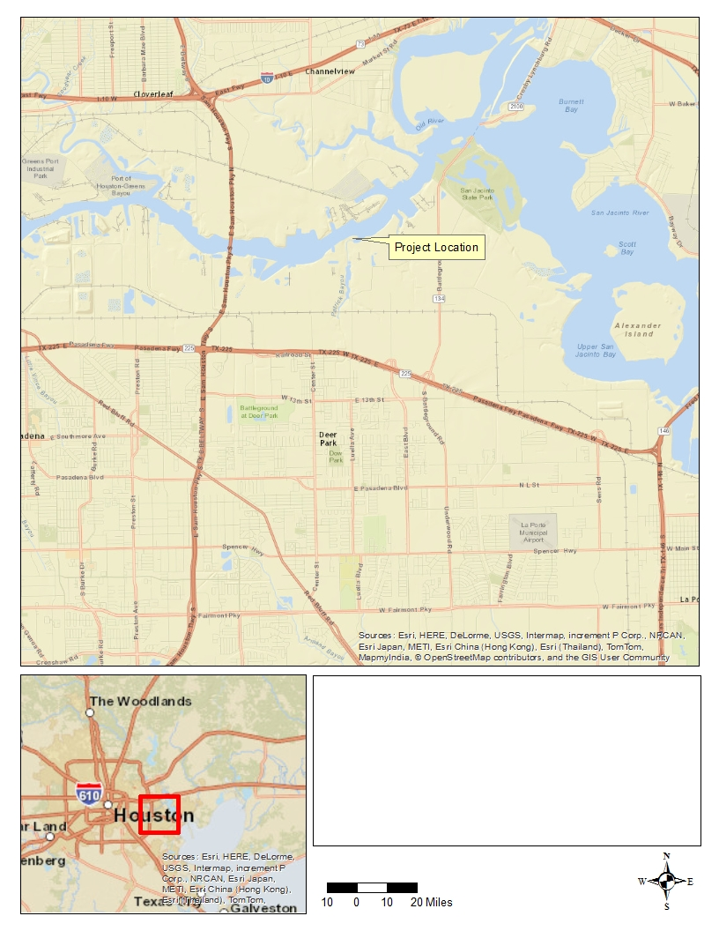
Figure 1. Overview Map

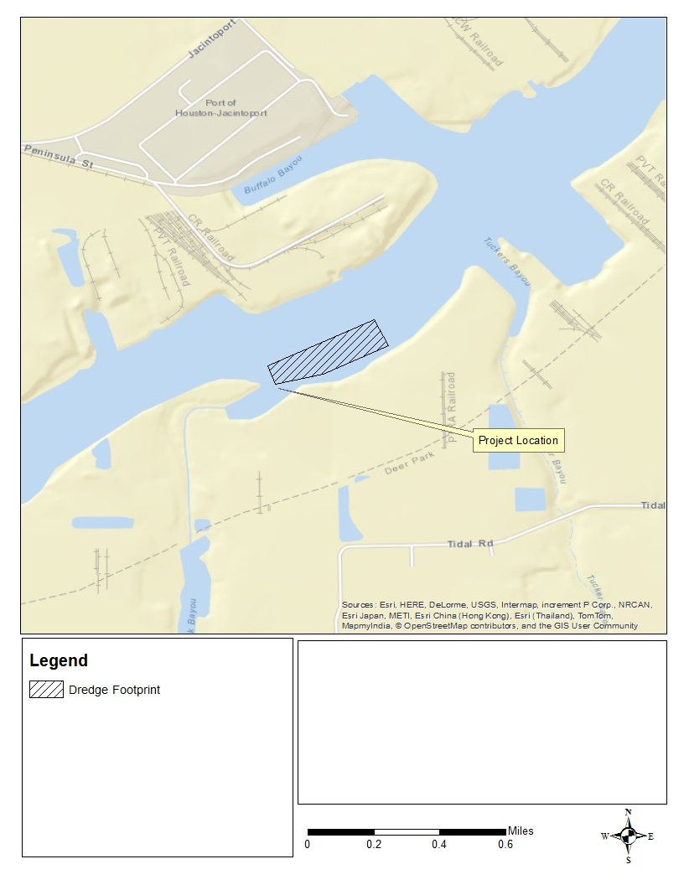
Figure 2. Plan View

Figure 3. Cross Section

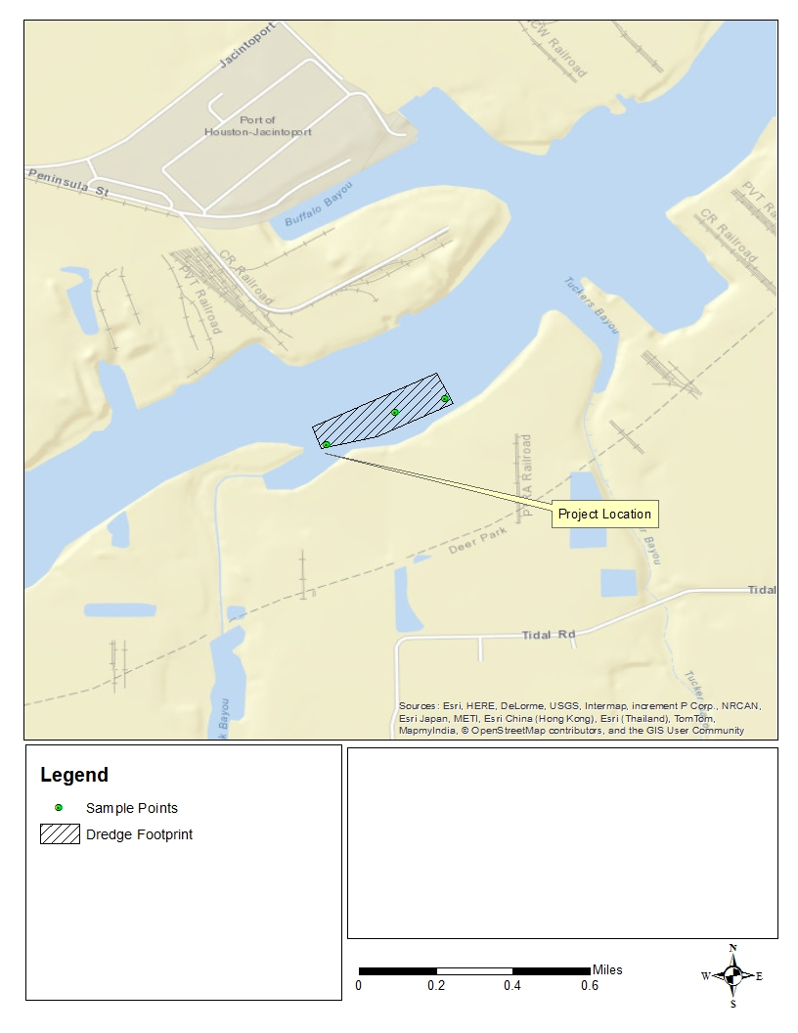
Figure 4. Sample Locations

ATTACHMENT 2 – SAP

ATTACHMENT 3 – Case Narrative

CASE NARRATIVE

Job ID :

Client Name: Project ID:
Date Received:

Collected By:
________________

11/21/2013,11/25/2013

Client

28 Samples were collected on 11/21/2013 and were received at NWDLS on 11/21/2013 properly thermally preserved and intact. These samples received a job number of 1311221. The lab sample ID’s, Client Sample ID’s, and dates of collection are at the top of each result page. Except as noted below, all method specified calibrations and quality control performance criteria were met for this job. For additional information, please refer to the Quality Form pages.

Semi volatiles
Project requested TDL’s were not met for Benzidine or Isophorone in sediment samples.
QB13121604 - Samples 1311221- 01-09 had surrogate recoveries outside of the laboratory specified control limits.
LCS, LCSD, MS, MSD had a precision failure.
LCS, LCSD, MS had surrogate recoveries outside the laboratory specified control limits. Dimethyl Phthalate and Isophorone were present in the method blank.
QB13121605 - Samples 1310021- 1311221-11 thru 19 had surrogate recoveries outside of the laboratory specified control limits.
LCS, LCSD had a precision failure.
LCS, LCSD, MB had surrogate recoveries outside the laboratory specified control limits. Dimethyl Phthalate was present in the method blank.
QB13121703 - LCS, LCSD, MS, MSD had precision failures. Isophorone was present in the method blank.

Organochlorine Pesticides
QB13121702 - MS had surrogate recoveries outside the laboratory specified control limits. Project requested TDL’s were not met on water samples for dieldrin.
QB13121606 - MSD had a precision failure. QB13121701 - MS, MSD had a precision failure.

Mercury

QB13120303 - MS had a precision failure.

Ammonia

QB13121001 - DUP2 had a precision failure.
Project requested TDL’s were not met for water or sediment samples.

Metals

Project requested TDL’s were not met on water samples for Zinc, Trivalent Chromium, or Hexavalent Chromium.

Total Petroleum Hydrocarbons
Project requested TDL’s were not met for water or sediment samples. All sediment samples were extracted out of hold time.

Polychlorinated Biphenyls
Project requested TDL’s were not met for water samples.

Project Manager

Date:
12/31/2013 14:19

Page 2 of 184
Certification #

ATTACHMENT 4 - TABLES

TABLE 1

STANDARD PARAMETERS

Channel
Water
Depth
Dissolved
Oxygen Salinity
Water
Temp
Air
Temp
Coordinates
Latitude (N) Longitude (W)

Station* Date Time Station (ft) (mg/L) pH (‰) (°C) (°C) Deg. Min. Sec. Deg. Min. Sec.

H-CT-13- | 13A | 11/21/2013 | 1000 | 1150+00 | 38.5 | 6.39 | 7.47 | 10.42 | 17.0 | 24.9 | 29 | 43 37.3 | 94 | 15 | 26.7
H-CT-13- | 13B | 11/21/2013 | 1015 | 1150+00 | 38.8 | 6.38 | 7.48 | 10.42 | 17.0 | 25.1 | 29 | 43 34.9 | 94 | 15 | 26.9
H-CT-13- | 14AA | 11/21/2013 | 1115 | 1210+00 | 44.5 | 6.56 | 7.34 | 8.61 | 17.4 | 25.3 | 29 | 43 39.6 | 95 | 16 | 27.4
H-CT-13- | 14AB | 11/21/2013 | 1125 | 1210+00 | 45.0 | 6.57 | 7.34 | 8.65 | 17.4 | 25.3 | 29 | 43 38.8 | 95 | 16 | 28.5
H-CT-13- | 14AC | 11/21/2013 | 1135 | 1210+00 | 43.0 | 6.55 | 7.33 | 8.61 | 17.5 | 25.4 | 29 | 43 38.0 | 95 | 16 | 29.6
H-CT-13- | 15A | 11/21/2013 | 1145 | 1250+00 | 42.0 | 6.56 | 7.36 | 8.14 | 17.5 | 26.7 | 29 | 44 15.8 | 95 | 16 | 43.6
H-CT-13- | 15B | 11/21/2013 | 1150 | 1250+00 | 41.5 | 6.57 | 7.35 | 8.14 | 17.5 | 26.8 | 29 | 44 15.3 | 95 | 16 | 45.0
H-CT-13- | 15C | 11/21/2013 | 1205 | 1250+00 | 39.5 | 6.57 | 7.36 | 8.13 | 17.4 | 27.1 | 29 | 44 14.8 | 95 | 16 | 46.3
H-CT-13- | 16A | 11/21/2013 | 1220 | 0+00 | 39.0 | 6.33 | 7.38 | 6.04 | 18.5 | 26.8 | 29 | 44 41.7 | 95 | 17 | 3.5
H-CT-13- | 16B | 11/21/2013 | 1226 | 0+00 | 39.0 | 5.92 | 7.36 | 6.05 | 18.5 | 27.8 | 29 | 44 41.2 | 95 | 17 | 4.4
H-CT-13- | 16C | 11/21/2013 | 1239 | 0+00 | 38.0 | 6.00 | 7.37 | 6.04 | 18.5 | 27.3 | 29 | 44 40.8 | 95 | 17 | 5.4
H-CT-13- | 17A | 11/21/2013 | 1250 | 25+00 | 38.5 | 6.53 | 7.21 | 4.50 | 19.2 | 27.3 | 29 | 45 3.0 | 95 | 17 | 17.9
H-CT-13- | 17B | 11/21/2013 | 1255 | 25+00 | 41.0 | 6.50 | 7.18 | 4.52 | 19.2 | 27.3 | 29 | 45 1.6 | 95 | 17 | 20.9
H-CT-13- | 17C | 11/21/2013 | 1310 | 25+00 | 39.0 | 6.51 | 7.18 | 4.51 | 19.2 | 27.3 | 29 | 45 0.3 | 95 | 17 | 23.9
H-CT-13- | 18A | 11/21/2013 | 1320 | 9+00-A | 29.0 | 6.44 | 7.21 | 2.99 | 18.5 | 27.8 | 29 | 44 52.0 | 95 | 17 | 32.4
H-CT-13- | 18B | 11/21/2013 | 1325 | 9+00-A | 32.5 | 6.45 | 7.21 | 3.00 | 18.5 | 27.8 | 29 | 44 51.6 | 95 | 17 | 32.1
H-CT-13- | 18C | 11/21/2013 | 1335 | 9+00-A | 35.0 | 6.47 | 7.21 | 2.95 | 18.5 | 27.2 | 29 | 44 51.2 | 95 | 17 | 31.8
H-B1-13- | 01A | 11/21/2013 | 1035 | 15+00 | 15.0 | 5.71 | 7.35 | 10.27 | 16.9 | 24.9 | 29 | 43 15.7 | 95 | 16 | 25.6
H-B1-13- | 02A | 11/21/2013 | 1100 | 30+00 | 2.5 | 5.80 | 7.48 | 8.72 | 17.1 | 25.0 | 29 | 43 23.7 | 95 | 16 | 36.4

TABLE 2

PARAMETERS DETERMINED BY CHEMICAL ANALYSIS

METALS
Antimony Lead Arsenic Mercury Beryllium Nickel Cadmium Selenium Chromium, Total Silver Chromium, Trivalent Thallium Chromium. Hexavalent Zinc Copper

PESTICIDES AND PCBs
Aldrin Dieldrin Alpha-BHC Endosulfan I Beta-BHC Endosulfan II
Delta-BHC Endosulfan sulfate
Gamma-BHC (Lindane) Endrin Chlordane Endrin aldehyde Alpha-Chlordane Heptachlor
Gamma- Chlordane Heptachlor epoxide
4,4'-DDD Toxaphene
4,4'-DDE Total PCBs
4,4'-DDT

SEMIVOLATILES
Acenaphthene Dimethyl phthalate Acenaphthylene Di-n-butyl phthalate Anthracene 2,4-Dinitrotoluene Benzidine 2,6-Dinitrotoluene Benzo(a)anthracene Di-n-octyl phthalate Benzo(a)pyrene 1,2-Diphenylhydrazine Benzo(ghi)perylene Fluoranthene Benzo(b&k)fluoranthene Fluorene
Bis(2-chloroethyoxy)methane Hexachlorobenzene
Bis(2-chloroethyl)ether Hexachlorobutadiene
Bis(2-chloroisoproply)ether Hexachlorocyclopentadiene
Bis(2-ethylhexyl)phthalate Hexachloroethane
4-Bromophenyl phenyl ether Indeno(123-CD)pyrene
Butyl benzyl phthalate Isophorone
4-chloro-3-methylphenol 2-Methyl-4,6-dinitrophenol (4,6-dinitro-o-cresol)
2-Chloronapthalene Naphthalene
2-Chlorophenol Nitrobenzene
4-Chlorophenyl phenyl ether 2-Nitrophenol Chrysene 4-Nitrophenol Dibenzo(ah)anthracene N-nitrosodimethylamine**
1,2-Dichlorobenzene N-nitrosodi-n-propylamine
1,3-Dichlorobenzene N-nitrosodiphenylamine
1,4-Dichlorobenzene Phenanthrene
3,3'-Dichlorobenzidine Phenol
2,4-Dichlorophenol Pentachlorophenol
2,4-Dinitrophenol Pryene
Diethyl phthalate 1,2,4-Trichlorobenzene
2,4-Dimethylphenol 2,4,6-Trichlorophenol

TABLE 2 (Concluded)

PARAMETERS DETERMINED BY CHEMICAL ANALYSIS

CONVENTIONAL PARAMETERS
Ammonia Total Petroleum Hydrocarbons
Cyanide % Solids* Total Organic Carbon Grain Size*

DIOXIN/FURAN CONGENERS*

2,3,7,8 - Tetrachloro Dibenzo-p -Dioxin
1,2,3,7,8 - Pentachloro Dibenzo-p-Dioxin 1,2,3,7,8,9 - Hexachloro Dibenzo-p-Dioxin
1,2,3,4,7,8 - Hexachloro Dibenzo-p-Dioxin 1,2,3,4,6,7,8 - Heptachloro Dibenzo-p-Dioxin
1,2,3,6,7,8 - Hexachloro Dibenzo-p-Dioxin Octachloro Dibenzo-p-Dioxin

2,3,7,8 - Tetrachloro Dibenzo-p-Furan 2,3,4,6,7,8 - Hexachloro Dibenzo-p-Furan
1,2,3,7,8 - Pentachloro Dibenzo-p-Furan 1,2,3,7,8,9 - Hexachloro Dibenzo-p-Furan
2,3,4,7,8 - Pentachloro Dibenzo-p-Furan 1,2,3,4,6,7,8 - Heptachloro Dibenzo-p-Furan
1,2,3,4,7,8 - Hexachloro Dibenzo-p-Furan 1,2,3,4,7,8,9 - Heptachloro Dibenzo-p-Furan
1,2,3,6,7,8 - Hexachloro Dibenzo-p-Furan Octachloro Dibenzo-p-Furan

* sediment only
** Water/elutriate only

TABLE 3

CONCENTRATIONS OF DETECTED COMPOUNDS (ug/L) WATER

Date Sampled: November 21, 2013
WQS*

CRDL Lab H-CT-13 H-B1-13-

Parameter RL 13 14A 15 15 16 17 18 01 02 Metals
Dup Blank

Antimony N/A 3 1.00 1.22 1.03 1.15 1.40 1.38 1.40 1.10 1.83 1.31 0.691 J Arsenic 149 1 0.50 6.24 5.14 5.08 4.81 4.59 3.79 3.82 5.82 4.93 0.406 J Beryllium N/A 0.2 0.50 BDL BDL BDL 0.069 J BDL BDL BDL 0.116 J 0.0672 J 0.134 J Cadmium 40 1 0.50 0.336 J BDL 0.228 J BDL 0.260 J 0.228 J BDL BDL BDL BDL Chromium, Total N/A 1 0.50 0.847 0.756 0.840 0.664 0.923 0.972 0.920 0.974 0.945 0.350 J Chromium, Hexavalent N/A 1 10.0 BDL BDL BDL BDL 2.20 J BDL BDL BDL BDL NA Copper 13.5 1 1.00 3.23 2.93 3.07 3.50 3.07 3.28 3.26 3.23 2.95 BDL
Lead 133 1 0.50 BDL BDL BDL BDL BDL 0.253 J BDL 0.296 J BDL 0.296 J Nickel 118 1 1.00 3.87 3.48 4.23 3.94 5.11 5.78 4.74 4.97 3.82 0.362 J Selenium 564 2 0.001 0.0177 0.0115 0.0143 0.0141 0.0108 0.00687 0.00585 0.0176 0.0154 0.00109
Silver 2 1 0.50 0.0794 J BDL BDL 0.243 J BDL BDL BDL 0.116 J 0.084 J 0.0935 J Thallium N/A 1 0.50 BDL BDL BDL BDL BDL BDL BDL 0.634 BDL 0.235 J Zinc 92.7 1 5.00 14.0 14.8 15.7 14.6 21.4 55.0 21.2 15.1 16.6 2.46 J
Ammonia** N/A 0.07 0.50 0.756 1.48 0.728 0.364 J 0.364 J 0.392 J 0.140 J 2.04 0.420 J NA TOC (%) N/A 0.10 1.00E-04 6.34E-04 6.40E-04 6.13E-04 6.23E-04 7.02E-04 7.34E-04 7.15E-04 5.92E-04 6.24E-04 NA TPH** N/A 0.10 2.4 BDL BDL BDL BDL BDL BDL BDL 1.16 J BDL NA
2,4-Dinitrotoluene N/A 2 10 1.45 J 1.47 J 1.48 J 1.49 J 1.50 J 1.39 J 1.45 J 1.45 J 1.48 J NA
2,6-Dinitrotoluene N/A 2 2.0 0.370 J 0.790 J 0.600 J 2.84 0.730 J 0.980 J 0.540 J 1.98 J 1.71 J NA
3,3-Dichlorobenzene N/A 3 3.0 BDL BDL BDL 0.160 J BDL BDL BDL BDL BDL NA
4-Nitrophenol N/A 5 5.0 BDL BDL BDL 5.53 BDL BDL BDL 4.38 J 3.38 J NA Acenaphthene N/A 0.75 0.75 BDL BDL BDL BDL BDL BDL BDL BDL BDL NA Benzidine N/A 1 1.0 BDL 2.00 BDL BDL 1.82 2.16 1.69 BDL BDL NA Bis(2-Chloroisopropyl)ether N/A 0.7 0.7 BDL BDL BDL 0.120 J BDL BDL BDL BDL BDL NA Bis(2-ethylhexyl)phthalate N/A 2 2.0 BDL BDL BDL 1.19 J BDL BDL BDL 0.850 J 0.590 J NA Diethyl phthalate N/A 1 1.0 BDL 0.140 J BDL 0.490 J BDL BDL BDL 0.340 J 0.320 J NA Dimethyl phthalate N/A 1 1.0 8.32 B 14.8 B 13.5 B 59.5 B 12.1 B 15.9 B 8.20 B 42.8 B 44 B NA Di-n-butyl phthalate N/A 1 1.0 0.190 J BDL BDL 3.67 BDL BDL BDL 1.86 1.33 NA Fluoranthene N/A 0.90 0.90 BDL BDL BDL BDL BDL BDL BDL BDL BDL NA Fluorene N/A 0.60 0.60 BDL BDL BDL BDL BDL BDL BDL BDL BDL NA Isopheron N/A 1 1.0 0.830 BJ 1.40 B 1.22 B 0.610 BJ 1.15 B 1.10 B 0.930 BJ BDL 0.770 BJ NA Nitrobenzene N/A 0.9 0.9 BDL 0.100 J BDL BDL BDL BDL BDL BDL BDL NA N-Nitrosodimethylamine N/A 3.1 3.1 0.260 J 0.370 J 0.470 J 0.150 J 0.340 J 0.230 J 0.140 J 0.160 J 0.150 J NA N-Nitrosodi-n-propylamine N/A 0.9 0.9 BDL BDL BDL 0.260 J BDL 0.130 J BDL 0.130 J 0.210 J NA N-Nitrosodiphenylamine N/A 2.1 2.1 BDL BDL BDL 0.170 J BDL 0.150 J BDL 0.320 J 0.190 J NA Phenanthrene 7.7 0.50 0.50 BDL BDL BDL BDL BDL BDL BDL BDL BDL NA Phenol N/A 10 10 0.330 J 0.830 J 0.500 J 2.40 J 0.650 J 0.570 J 0.550 J 2.28 J 1.49 J NA Pyrene N/A 1.50 1.50 BDL BDL BDL BDL BDL BDL BDL BDL BDL N/A

Dup = Duplicate Sample
BDL = Below Detection Limits
* Acute Texas Water Quality Standards for Saltwater
** mg/L
J-Estimated result since result was less than reporting limit,
B=Method Blank Contamination (associated method blank contains the target analyte at a reportable level).

TABLE 4
CONCENTRATIONS OF DETECTED COMPOUNDS (ug/L) ELUTRIATE

Date Sampled: November 21, 2013
WQS*

CRDL Lab H-CT-13 H-B1-13-

Parameter RL 13 14A 15 15 16 17 18 01 02
Dup

Antimony N/A 3 1.00 2.10 4.82 1.66 1.93 1.53 1.70 1.23 2.08 2.32
Arsenic 149 1 0.50 2.10 17.0 10.8 11.6 5.86 5.75 3.34 4.68 5.52
Beryllium N/A 0.2 0.50 BDL BDL BDL 0.0796 J BDL BDL BDL BDL BDL Cadmium 40 1 0.50 BDL BDL BDL 0.259 J BDL BDL BDL BDL BDL Chromium, Total N/A 1 0.50 1.05 0.801 0.971 1.06 0.632 0.766 0.655 0.632 0.649
Chromium, Hexavalent N/A 1 10.0 BDL 3.40 J BDL BDL 2.30 J BDL 2.10 J BDL 2.30 J Copper 13.5 1 1.00 1.47 0.839 J 0.854 J 1.51 0.828 J 0.695 J 0.703 J 5.10 1.04
Lead 133 1 0.50 0.499 J 0.361 J 0.443 J 0.526 BDL 0.325 J BDL 0.594 BDL
Nickel 118 1 1.00 3.84 3.55 4.17 3.90 5.80 5.95 5.73 5.94 3.36
Selenium 564 2 0.001 0.0191 0.0147 0.0161 0.0157 0.0146 0.00937 0.00661 0.0159 0.0132
Silver 2 1 0.50 BDL BDL BDL 0.0732 J BDL BDL BDL BDL BDL Thallium N/A 1 0.50 BDL BDL BDL 0.182 J BDL BDL BDL BDL BDL Zinc 92.7 1 5.00 12.8 8.93 8.72 9.30 11.10 9.76 12.6 17.9 10.8
Ammonia** N/A 0.07 0.50 7.64 BDL 5.68 0.450 J BDL 0.952 9.32 2.55 BDL TOC (%) N/A 0.10 1.00E-04 6.72E-04 8.41E-04 1.06E-03 1.04E-03 1.15E-03 1.10E-03 1.03E-03 1.01E-03 6.87E-04
TPH** N/A 0.10 2.4 BDL BDL BDL BDL BDL BDL BDL BDL BDL

2,4-Dinitrotoluene N/A 2.00 10.0 1.44 J 1.51 J 1.42 J 1.47 J 1.47 J 1.44 J BDL BDL 1.45 J
2,6-Dinitrotoluene N/A 2.00 2.00 0.180 J 0.170 J 0.480 J 0.250 J 1.12 J 1.09 J 0.870 J BDL 0.140 J
3,3-Dichlorobenzene N/A 3.00 3.00 BDL BDL BDL BDL BDL BDL BDL BDL BDL
4-Nitrophenol N/A 5.00 5.00 BDL BDL 1.26 J 1.63 J 1.91 J 2.26 J BDL BDL BDL Acenaphthene N/A 0.75 0.75 BDL BDL BDL BDL BDL BDL 0.420 J BDL BDL Benzidine N/A 1.00 1.00 BDL BDL BDL BDL 0.840 J BDL 1.11 BDL BDL Bis(2-Chloroisopropyl)ether N/A 0.70 0.70 0.230 J BDL BDL BDL 0.110 J 0.350 J BDL BDL BDL
Bis(2-ethylhexyl)phthalate N/A 2.00 2.00 2.10 3.89 0.480 J 2.43 0.710 J 1.81 J 2.95 2.89 1.42 J Diethyl phthalate N/A 1.00 1.00 BDL BDL 0.140 J BDL 0.220 J 0.210 J 0.160 J BDL BDL Dimethyl phthalate N/A 1.00 1.00 6.08 B 5.39 B 8.83 B 13.8 B 20.4 B 17.1 B 12.7 B 13.8 B 5.34 B Di-n-butyl phthalate N/A 1.00 1.00 0.180 J BDL 0.210 J BDL 0.290 J 0.210 J BDL BDL 0.230 J Fluoranthene N/A 0.90 0.90 BDL BDL BDL BDL BDL BDL 0.210 J BDL BDL Fluorene N/A 0.60 0.60 BDL BDL BDL BDL BDL BDL 0.320 J BDL BDL Isopheron N/A 1.00 1.00 0.950 J 0.650 J BDL BDL BDL BDL BDL BDL 0.620 J Nitrobenzene N/A 0.90 0.90 BDL BDL 0.110 J BDL BDL BDL BDL BDL BDL
N-Nitrosodimethylamine N/A 3.10 3.10 0.150 J 0.150 J 0.140 J 0.170 J BDL BDL BDL 0.170 J 0.130 J N-Nitrosodi-n-propylamine N/A 0.90 0.90 BDL BDL 0.130 J BDL 0.330 J BDL BDL 0.210 J BDL
N-Nitrosodiphenylamine N/A 2.10 2.10 0.150 J 0.120 J BDL 0.210 J BDL BDL BDL 0.210 J 0.120 J Phenanthrene 7.7 0.50 0.50 BDL BDL BDL BDL BDL BDL 0.460 J BDL BDL Phenol N/A 10.0 10.0 0.330 J 0.380 J 0.680 J 0.510 J 0.600 J 0.570 J 0.390 J 0.530 J 0.360 J Pyrene N/A 1.50 1.50 BDL 0.130 J BDL BDL BDL BDL 0.130 J 0.410 J BDL

Dup = Duplicate Sample
BDL = Below Detection Limits
* Acute Texas Water Quality Standards for Saltwater
** mg/L
J-Estimated result since result was less than reporting limit,
B=Method Blank Contamination (associated method blank contains the target analyte at a reportable level).

TABLE 5

Date Sampled: November 21, 2013
CONCENTRATIONS OF DETECTED COMPOUNDS (dry weight) SEDIMENT

Contract H-CT-13 H-B1-13- Required NOAA NOAA TCEQ 13 14A 15 15 16 17 18 01 02

Parameter Units Detection ERM ERL PEL Dup
Limit

Antimony | mg/kg | 2.5 | N/A | N/A | 15 | 0.358 |  | 0.378 |  | 0.357 | P | 0.494 | P | 0.334 |  | 0.207 | J | 0.232 |  | 0.331 |  | 0.570
Arsenic | mg/kg | 0.3 | 70 | 8.2 | 24 | 4.35 |  | 8.12 |  | 4.28 | P | 4.04 | P | 3.46 |  | 0.824 |  | 2.60 |  | 5.33 |  | 7.83
Beryllium | mg/kg | 1 | N/A | N/A | 38 | 1.04 |  | 0.834 |  | 1.04 |  | 1.01 |  | 0.869 |  | 0.824 |  | 0.605 |  | 0.457 |  | 0.761
Cadmium | mg/kg | 0.1 | 9.6 | 1.20 | 52 | 0.960 |  | 2.33 |  | 1.01 |  | 1.03 |  | 0.663 |  | 0.588 |  | 0.448 |  | 0.745 |  | 1.04
Chromium, Total | mg/kg | 1 | 370 | 81.0 | 3.3E+04 | 31.8 |  | 42.3 |  | 24.7 |  | 24.3 | P | 18.4 |  | 16.9 |  | 12.7 |  | 28.0 |  | 31.1
Chromium III | mg/kg | 1 | N/A | N/A | 3.3E+04 | 31.8 |  | 42.3 |  | 24.7 |  | 24.3 |  | 18.4 |  | 16.9 |  | 12.7 |  | 28.0 |  | 31.1
Copper | mg/kg | 1 | 270 | 34.0 | 550 | 66.5 |  | 72.8 |  | 62.3 | P | 59.0 | P | 37.5 |  | 32.5 |  | 25.8 |  | 76.6 |  | 118
Lead | mg/kg | 0.3 | 218 | 46.7 | 500 | 50.9 |  | 116 |  | 49.9 |  | 49.7 | P | 38.7 |  | 35.3 |  | 31.5 |  | 82.2 |  | 72.0
Mercury | mg/kg | 0.2 | 0.71 | 0.15 | 3.6a | 0.175 | J | 0.301 |  | 0.121 | J | 0.140 | J | 0.100 | J | 0.097 | J | 0.060 | J | 0.188 | J | 0.194 | J
Nickel | mg/kg | 0.5 | 51.6 | 20.9 | 840 | 16.2 |  | 18.1 |  | 16.1 |  | 15.5 | P | 13.5 |  | 12.4 |  | 9.98 |  | 13.8 |  | 15.7
Selenium | mg/kg | 0.5 | N/A | N/A | 310 | 0.991 | J | 0.626 | J | 0.569 | J,P | 0.994 | P | 0.570 | J | 0.485 |  | 0.385 | J | 0.565 |  | 0.691
Silver | mg/kg | 0.2 | 3.7 | 1 | 97 | 0.727 |  | 2.20 |  | 0.824 |  | 0.789 |  | 0.537 |  | 0.538 | J | 0.370 |  | 0.0181 |  | 1.06
Thallium | mg/kg | 0.2 | N/A | N/A | 6 | 0.162 | J | 0.139 | J | 0.126 | J | 0.396 | P | 0.346 |  | 0.112 | J | 0.0748 | J | 0.263 |  | 0.174 | J
Zinc | mg/kg | 2 | 410 | 150 | 9900 | 257 |  | 391 |  | 263 | P | 254 | P | 197 |  | 178 |  | 147 |  | 425 |  | 432
Aldrin | ug/kg | 3 | N/A | N/A | 590 | 1.33 | J | 1.286 | J | 1.768 | J | 1.875 | J | 2.36 | J | 3.64 | J | 2.79 | J | 1.163 | J | 0.917 | J
Chlordane | ug/kg | 3 | 6 | 0.5 | 6000c | 25.9 | J | 25.6 | J | 27.3 | J | 26.9 | J | 29.1 | J | 29.3 | J | 30.8 | J | 26.3 | J | 33.4 | J
α-Chlordane | ug/kg | 3 | N/A | N/A | 13000c | 8.56 | J | 4.98 | J | 9.88 | J | 8.86 | J | 11.31 |  | 11.62 |  | 12.87 |  | 6.74 | J | 11.58
γ-Chlordane | ug/kg | 3 | N/A | N/A | 7400c | 14.44 |  | 13.13 |  | 15.06 |  | 15.50 |  | 15.04 |  | 14.26 |  | 15.09 |  | 14.43 |  | 18.89
Dieldrin | ug/kg | 5 | 6 | 0.02 | 150c | 3.80 | J | 9.62 | J | 3.91 | J | 8.47 | J | 3.32 | J | 4.03 | J | 4.46 | J | 7.78 | J | 8.59 | J
4,4'-DDD | ug/kg | 5 | 20 | 2 | 14000c | < 0.0309 |  | 3.35 | J | < 0.0309 |  | < 0.0309 |  | < 0.0309 |  | < 0.0309 |  | 2.98 | J | < 0.0309 |  | 2.03 | J
4,4'-DDE | ug/kg | 5 | 27 | 2 | 10000c | 8.70 | J | 22.2 |  | 5.18 | J | 5.72 | J | 3.29 | J | 5.96 | J | 8.69 | J | 8.36 | J | 6.74 | J
4,4'-DDT | ug/kg | 5 | 7 | 1 | 5400c | 18.3 |  | 49.6 |  | 71.2 |  | 36.1 |  | 11.3 |  | 11.1 |  | 9.14 | J | 51.5 |  | 29.7
Endosulfan I | ug/kg | 5 | N/A | N/A | 9.1E+04 | 2.47 | J | 0.790 | J | 2.32 | J | 1.24 | J | < 0.0193 |  | < 0.0193 |  | < 0.0193 |  | 0.753 | J | 1.34 | J
Endosulfan II | ug/kg | 5 | N/A | N/A | 2.7E+05 | 7.21 | J | 13.01 |  | 5.01 | J | 11.17 |  | 3.11 | J | 2.3 | J | 2.451 | J | 12.62 |  | 11.96
Endosulfan Sulfate | ug/kg | 5 | N/A | N/A | 3.8E+05 | 10.53 |  | 17.48 |  | 16.98 |  | 15.06 |  | 20.6 |  | 19.71 |  | 18.01 |  | 6.67 | J | 10.72
Endrin | ug/kg | 5 | N/A | N/A | 9000 | 4.77 | J | 12.43 |  | 2.599 | J | 6.67 | J | 1.447 | J | 1.437 | J | 1.172 | J | 8.15 | J | 6.54 | J
Endrin Aldehyde | ug/kg | 5 | N/A | N/A | 19000 | 10.73 |  | 15.78 |  | 7.24 | J | 15.81 |  | 7.34 | J | 5.25 | J | 5.12 | J | 9.49 | J | 10.31
Endrin Ketone | ug/kg | 5 | N/A | N/A | 19000 | < 0.0201 |  | < 0.0201 |  | < 0.0201 |  | < 0.0201 |  | < 0.0201 |  | < 0.0201 |  | < 0.0201 |  | < 0.0201 |  | 7.25 | J
Heptachlor | ug/kg | 3 | N/A | N/A | 130c | 0.904 | J | 1.985 | J | 0.38 | J | 0.608 | J | 0.824 | J | 0.971 | J | < 0.0126 |  | 0.469 | J | 0.372 | J
Heptachlor Epoxide | ug/kg | 3 | N/A | N/A | 240c | 1.78 | J | 5.40 | J | 1.82 | J | 1.67 | J | 1.64 | J | 2.21 | J | 2.74 | J | 4.59 | J | 2.26 | J
α-BHC | ug/kg | 3 | N/A | N/A | 260c | 1.569 | J | 1.546 | J | 1.115 | J | 0.80 | J | 1.106 | J | 1.17 | J | 1.154 | J | 0.642 | J | 0.796 | J
β-BHC | ug/kg | 3 | N/A | N/A | 930c | 5.82 | J | 4.07 | J | 2.14 | J | 1.244 | J | 1.02 | J | 1.164 | J | 2.74 | J | 1.468 | J | 3.49 | J
δ-BHC | ug/kg | 3 | N/A | N/A | 2900c | 2.079 | J | 1.792 | J | BDL |  | 3.44 | J | BDL |  | BDL |  | 2.595 | J | BDL |  | 3.44 | J
γ-BHC (Lindane) | ug/kg | 3 | N/A | N/A | 1100c | 2.561 | J | 1.106 | J | 2.179 | J | 0.994 | J | 1.926 | J | 1.633 | J | 2.318 | J | 2.000 | J | 2.840 | J
Toxaphene | ug/kg | 50 | N/A | N/A | 1200c | BDL |  | 284 | J | BDL |  | BDL |  | BDL |  | BDL |  | BDL |  | BDL |  | BDL
Total PCBs | ug/kg | 1 | 180 | 22.7 | 1100.0 | 50.7 |  | 116 |  | 25.6 |  | 35.6 |  | 21.3 |  | 18.5 |  | 16.7 |  | 63.2 |  | 54.7
Dup = Duplicate Sample
BDL = Below Detection Limit
J = The reported value is between the limit of detection (MDL) and the practical quantitation limit (RL), B = Analyte was found in the associated method blank.
P = Spike recovery outside control limits, possibly due to matrix interference.
a = At pH=4.9, would be greater at pH expected inside an UCPA.
PEL = TCEQ human health protective concentration levels as listed in 30 TAC §350, Table 4, Combined Tier 1 Soil PCLs, Residential, June 29, 2012.

Date Sampled: November 21 2013

Contract H-CT-13 H-B1-13- Required NOAA NOAA TCEQ 13 14A 15 15 16 17 18 01 02

Parameter Units Detection ERM ERL PEL Dup
Limit

Dup = Duplicate Sample
2,4-Dinitrotoluene | ug/kg | 200 | N/A | N/A | 6900c | 130 |  | 43.2 |  | 122.5 |  | 117.2 |  | 98.1 |  | 128.9 |  | 110.4 |  | 99.3 |  | 96.6
2,6-Dinitrotoluene | ug/kg | 200 | N/A | N/A | 6900c | 151.6 |  | 63.5 |  | 139.6 |  | 150.8 |  | 107 |  | 152.2 |  | 121.9 |  | 117.8 |  | 112.5
3,3-Dichlorobenzidine | ug/kg | 300 | N/A | N/A | 10000c | BDL |  | BDL |  | BDL |  | BDL |  | BDL |  | BDL |  | BDL |  | 25.4 |  | BDL
2-Nitrophenol | ug/kg | 200 | N/A | N/A | 1.3E+05 | 182.6 |  | 122 |  | 257 |  | BDL |  | 177.8 |  | 227.8 |  | 179.8 |  | 136.6 |  | 155.8
4-Nitrophenol | ug/kg | 500 | N/A | N/A | 1.3E+05 | BDL |  | 570 |  | BDL |  | BDL |  | BDL |  | BDL |  | 616 |  | 1353 |  | BDL
Acenaphthene | ug/kg | 20 | 500 | 16 | 3.0E+06 | BDL |  | 155 |  | 24.9 |  | 21.3 |  | 27.7 |  | 27.3 |  | 49.6 |  | 369 |  | 39.4
Acenaphthylene | ug/kg | 20 | 640 | 44 | 3.8E+06 | 23.7 |  | 31.8 |  | 22.0 |  | 27.6 |  | 21.5 |  | BDL |  | 23.6 |  | 29.6 |  | 26.5
Anthracene | ug/kg | 20 | 1100 | 85.3 | 1.8E+07 | 71.8 |  | 313 |  | 86.7 |  | 86.1 |  | 547 |  | 83.8 |  | 113 |  | 2248 |  | 116
Benzo(a)anthracene | ug/kg | 20 | 1600 | 261 | 5700c | 1160 |  | 1190 |  | 671 |  | 1005 |  | 1023 |  | 876 |  | 962 |  | 3917 |  | 1738
Benzo(a)pyrene | ug/kg | 20 | 1600 | 430 | 560c | 1009 |  | 987 |  | 791 |  | 803 |  | 804 |  | 713 |  | 752 |  | 3958 |  | 1681
Benzo(b)fluoranthene | ug/kg | 20 | N/A | N/A | 5700c | 1796 |  | 1491 |  | 1385 |  | 1492 |  | 1463 |  | 1204 |  | 1310 |  | 5150 |  | 2711
Benzo(g,h,i)perylene | ug/kg | 20 | N/A | N/A | 1.8E+06 | 1045 |  | 767 |  | 856 |  | 792 |  | 883 |  | 773 |  | 801 |  | 2479 |  | 1631
Benzo(k)fluoranthene | ug/kg | 20 | N/A | N/A | 57000c | 1832 |  | 1521 |  | 1413 |  | 1522 |  | 1492 |  | 1230 |  | 1336 |  | 5265 |  | 2754
Bis(2-Chloroethyl)ether | ug/kg | 130 | N/A | N/A | 2200c | BDL |  | BDL |  | BDL |  | BDL |  | BDL |  | 35.5 |  | 33.2 |  | BDL |  | BDL
Bis(2-ethylhexyl)phthalate | ug/kg | 50 | N/A | N/A | 2.7E+05 | 1534 |  | 2824 |  | BDL |  | 1494 |  | 1504 |  | 1308 |  | 1260 |  | 1066 |  | 1974
Buthyl benzyl phthalate | ug/kg | 50 | N/A | N/A | 1.0E+07 | 65.1 |  | 39.4 |  | 44.5 |  | 48.6 |  | 52.9 |  | 62.2 |  | 122.7 |  | 28.6 |  | 93
Chrysene | ug/kg | 20 | 2800 | 384 | 560000c | 1139 |  | 1163 |  | 988 |  | 969 |  | 1074 |  | 923 |  | 992 |  | 4208 |  | 1758
Dibenzo(a,h)anthracene | ug/kg | 20 | 260 | 63.4 | 55000c | 183.2 |  | 29.2 |  | 38.9 |  | 138.9 |  | 138.3 |  | 131.2 |  | 131.3 |  | 23.3 |  | 306
Dimethyl phthalate | ug/kg | 50 | N/A | N/A | 5.3E+07 | 42.4 |  | BDL |  | 32.7 |  | BDL |  | 32.3 |  | 26.27 |  | BDL |  | BDL |  | 18.92
Di-n-butyl phthalate | ug/kg | 50 | N/A | N/A | 6.2E+06 | 36 |  | 27.1 |  | 28.7 |  | BDL |  | 36.8 |  | 33.2 |  | 31.8 |  | 22.1 |  | 33.6
Di-n-octyl Phthalate | ug/kg | 50 | N/A | N/A | 2.6E+06 | 123.1 |  | 33.5 |  | 127.3 |  | 141.1 |  | 147.2 |  | 136 |  | 45.4 |  | 85.7 |  | 132.3
Fluoranthene | ug/kg | 20 | 5100 | 600 | 2.3E+06 | 1635 |  | 2478 |  | 1506 |  | 1472 |  | 1551 |  | 1321 |  | 1569 |  | 8378 |  | 2582
Fluorene | ug/kg | 20 | 540 | 19 | 2.3E+06 | BDL |  | 131 |  | 25.8 |  | 25.2 |  | 43.2 |  | 30.7 |  | 52.5 |  | 523 |  | 26.9
Indeno(1,2,3-cd)pyrene | ug/kg | 20 | N/A | N/A | 2700c | 995 |  | 741 |  | 814 |  | 764 |  | 845 |  | 750 |  | 767 |  | 2479 |  | 1549
Isopheron | ug/kg | 10 | N/A | N/A | 4900000c | 892 | B | 432 | B | 467 | B | 133.9 | B | 670 | B | 866 | B | 282 | B | 317 | B | 626 | B
Naphthalene | ug/kg | 20 | 2100 | 160 | 2.2E+05 | BDL |  | 53.2 |  | BDL |  | 12.2 |  | 18.8 |  | BDL |  | 32.9 |  | 155.6 |  | BDL
Nitrobenzene | ug/kg | 160 | N/A | N/A | 6600c | 60.7 |  | 31.1 |  | 32.9 |  | BDL |  | 30.9 |  | 63.9 |  | 830 |  | BDL |  | BDL
Phenanthrene | ug/kg | 20 | 1500 | 240 | 1.7E+06 | 344 |  | 775 |  | 332 |  | 328 |  | 525 |  | 395 |  | 613 |  | 6802 |  | 486
Pyrene | ug/kg | 20 | 2600 | 665 | 1.7E+06 | 1494 |  | 2224 |  | 1329 |  | 1283 |  | 1310 |  | 1133 |  | 1289 |  | 6533 |  | 2281
Ammonia | mg/kg | 0.1 | N/A | N/A | 1.5E+06 | 171 |  | 39.2 | J | 195 |  | 255 |  | 159 |  | 236 |  | 224 |  | 93.0 | J | 75.9 | J
TOC | % | 0.1 | N/A | N/A | N/A | 3.44 |  | 3.01 |  | 3.63 |  | 3.67 |  | 3.32 |  | 3.83 |  | 4.18 |  | 2.40 |  | 3.57
TPH | mg/kg | 5.0 | N/A | N/A | 2.3E+06 | 408 |  | 1350 |  | 243 |  | 247 |  | 270 |  | 341 |  | 303 |  | 1210 |  | 676
Cyanide | mg/kg | 2.0 | N/A | N/A | 48000 | BDL |  | BDL |  | BDL |  | BDL |  | BDL |  | BDL |  | BDL |  | BDL |  | 0.09 | J
Percent Solids | % | 0.1 | N/A | N/A | N/A | 36.1 |  | 47.2 |  | 35.5 |  | 36.0 |  | 44.0 |  | 35.2 |  | 38.3 |  | 52.0 |  | 46.5
Gravel | % N/A |  | N/A | N/A |  | 0.0 |  | 0.0 |  | 0.0 |  | 0.0 |  | 0.0 |  | 0.0 |  | 0.0 |  | 0.0 |  | 0.0
Sand | % N/A |  | N/A | N/A |  | 13.5 |  | 18.7 |  | 8.9 |  | 7.3 |  | 12.7 |  | 14.8 |  | 34.2 |  | 47.6 |  | 22.7
Silt | % N/A |  | N/A | N/A |  | 65.7 |  | 58.6 |  | 69.4 |  | 68.0 |  | 68.1 |  | 67.8 |  | 51.9 |  | 39.3 |  | 62.3
Clay | % N/A |  | N/A | N/A |  | 20.8 |  | 22.7 |  | 21.7 |  | 24.7 |  | 19.2 |  | 17.4 |  | 13.9 |  | 13.1 |  | 15.0
D50 | mm N/A |  | N/A | N/A |  | 0.013 |  | 0.015 |  | 0.012 |  | 0.011 |  | 0.016 |  | 0.017 |  | 0.032 |  | 0.055 |  | 0.024

BDL = Below Detection Limit
J = The reported value is between the limit of detection (MDL) and the practical quantitation limit (RL), B = Analyte was found in the associated method blank. P = Spike recovery outside control limits, possibly due to matrix interference.
PEL = TCEQ human health protective concentration levels as listed in 30 TAC §350, Table 4, Combined Tier 1 Soil PCLs, Residential, June 29, 2012.

Contract |  |  |  |  |  | H-CT-13 |  |  |  |  | H-B1-13-
Required | NOAA NOAA | TCEQ | 13 | 14A | 15 | 15 | 16 | 17 | 18 | 01 | 02
Parameter Units Detection ERM ERL PEL Dup
Limit

UN-NORMALIZED DATA as TEQs
2,3,7,8-TCDD pg/g N/A N/A 26.1 14.3 6.29 10.0 0.970 J 0.85 J 0.27 J 5.41 4.99
1,2,3,7,8-PeCDD pg/g N/A N/A 1.93 J 2.91 J 1.67 J 1.85 J 1.17 J 1.03 J 0.92 J 1.20 J 1.92 J
1,2,3,4,7,8-HxCDD pg/g N/A N/A 0.308 J 0.610 0.284 J 0.309 J 0.210 J 0.192 J 0.157 J 0.201 J 0.318 J
1,2,3,6,7,8-HxCDD pg/g N/A N/A 1.00 3.18 0.896 0.979 0.606 0.556 0.502 0.888 1.13
1,2,3,7,8,9-HxCDD pg/g N/A N/A 1.05 * 1.85 * 0.962 * 1.02 * 0.648 0.591 * 0.529 * 0.659 * 0.962 *
1,2,3,4,6,7,8-HpCDD pg/g N/A N/A 2.94 12.5 ** 2.84 3.22 2.20 1.83 1.60 2.66 3.29
OCDD pg/g N/A N/A 1.29 4.92 ** 1.22 1.49 0.978 E++ 0.807 0.726 0.99 1.36 ++
2,3,7,8-TCDF pg/g N/A N/A 6.02 3.85 1.58 2.42 0.291 0.254 0.148 J 1.61 1.48
1,2,3,7,8-PeCDF pg/g N/A N/A 0.111 J 0.105 U*** 0.0507 J 0.069 J 0.0216 J 0.0194 J 0.0148 J 0.0585 J 0.0633 J
2,3,4,7,8-PeCDF pg/g N/A N/A 0.846 J 1.16 J 0.516 J 0.654 J 0.279 J 0.261 J 0.207 J 0.531 J 0.693 J
1,2,3,4,7,8-HxCDF pg/g N/A N/A 0.979 * 1.73 * 0.560 * 0.686 * 0.312 J 0.280 J * 0.224 * 0.583 * 0.701 *
1,2,3,6,7,8-HxCDF pg/g N/A N/A 0.415 J 0.822 0.327 J 0.370 J 0.190 J 0.176 J 0.138 J 0.337 J 0.390 ***
2,3,4,6,7,8-HxCDF pg/g N/A N/A 0.236 J 0.477 J 0.255 J 0.271 J 0.153 J 0.142 J 0.115 J 0.194 J 0.235 J
1,2,3,7,8,9-HxCDF pg/g N/A N/A 0.035 J 0.059 J 0.026 U+ 0.033 J 0.015 J 0.013 U+ 0.0130 U+ 0.029 *** 0.034 J
1,2,3,4,6,7,8-HpCDF pg/g N/A N/A 0.621 1.59 0.559 0.638 0.415 0.359 0.314 0.542 0.675
1,2,3,4,7,8,9-HpCDF pg/g N/A N/A 0.0358 J 0.122 0.0289 J 0.0327 J 0.0213 J 0.0187 J 0.0160 *** 0.0325 J 0.0449 J OCDF pg/g N/A N/A 0.0525 0.123 0.0429 0.0474 0.0278 0.0263 0.0268 0.0309 0.0408
Total TEQ pg/g N/A N/A 1000 44.0 50.3 18.1 24.1 8.51 7.41 5.92 16.0 18.3
NORMALIZED DATA as TEQs per 1% Organic Carbon
2,3,7,8-TCDD pg/g N/A N/A 759 475 173 272 29 22 6 225 140
1,2,3,7,8-PeCDD pg/g N/A N/A 56.1 96.7 46.0 50.4 35.2 26.9 22.0 50.0 53.8
1,2,3,4,7,8-HxCDD pg/g N/A N/A 9.0 20.3 7.8 8.4 6.3 5.0 3.8 8.4 8.9
1,2,3,6,7,8-HxCDD pg/g N/A N/A 29.1 105.6 24.7 26.7 18.3 14.5 12.0 37.0 31.7
1,2,3,7,8,9-HxCDD pg/g N/A N/A 30.5 61.5 26.5 27.8 19.5 15.4 12.7 27.5 26.9
1,2,3,4,6,7,8-HpCDD pg/g N/A N/A 85.5 415.3 78.2 87.7 66.3 47.8 38.3 110.8 92.2
OCDD pg/g N/A N/A 37.5 163.5 33.6 40.6 29.5 21.1 17.4 41.3 38.1
2,3,7,8-TCDF pg/g N/A N/A 175.0 127.9 43.5 65.9 8.8 6.6 3.5 67.1 41.5
1,2,3,7,8-PeCDF pg/g N/A N/A 3.2 3.5 1.4 1.9 0.7 0.5 0.4 2.4 1.8
2,3,4,7,8-PeCDF pg/g N/A N/A 24.6 38.5 14.2 17.8 8.4 6.8 5.0 22.1 19.4
1,2,3,4,7,8-HxCDF pg/g N/A N/A 28.5 57.5 15.4 18.7 9.4 7.3 5.4 24.3 19.6
1,2,3,6,7,8-HxCDF pg/g N/A N/A 12.1 27.3 9.0 10.1 5.7 4.6 3.3 14.0 10.9
2,3,4,6,7,8-HxCDF pg/g N/A N/A 6.9 15.8 7.0 7.4 4.6 3.7 2.8 8.1 6.6
1,2,3,7,8,9-HxCDF pg/g N/A N/A 1.0 2.0 0.7 0.9 0.5 0.3 0.3 1.2 1.0
1,2,3,4,6,7,8-HpCDF pg/g N/A N/A 18.1 52.8 15.4 17.4 12.5 9.4 7.5 22.6 18.9
1,2,3,4,7,8,9-HpCDF pg/g N/A N/A 1.0 4.1 0.8 0.9 0.6 0.5 0.4 1.4 1.3
OCDF pg/g N/A N/A 1.5 4.1 1.2 1.3 0.8 0.7 0.6 1.3 1.1
Total TEQ pg/g N/A N/A 1278 1671 499 656 256 193 142 665 513
Dup = Duplicate Sample
BDL = Below Detection Limit
* EMPC (Estimated Maximum Possible Concentration) due to Merged Peak
** Reults are from 5X Dilution.
*** EMPC due to Diphenylether interference present caused dibenzofuran detected to become a "non-detect" with an elevated detection limit.
+ EMPC because peak detected does not meet ratio criteria and has resulted in an elevated detection limit.
++ Exceeds Maximum Calibration Limit because - PCDD/DF - Exceeds maximum Calibration Limit.
J-Estimated result between EDL and RDL, B=Method Blank Contamination , E = Analyte concentration excceds the maximum concetration level, U=Undetected at the limit of quantitation. PEL = TCEQ human health protective concentration levels as listed in 30 TAC §350, Table 4, Combined Tier 1 Soil PCLs, Residential, June 29, 2012.

ATTACHMENT 5 – AUTHORIZED USACE PERMIT

